Alcoholometer reservoir

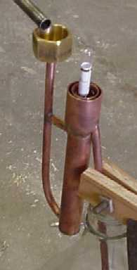

3/8 tubing
3/8 “T”
3/4 tube
3/4-1 1/4 reducer
3/4 cap
3/8- larger reducer (funnel)

